WILDERNESS CAMP

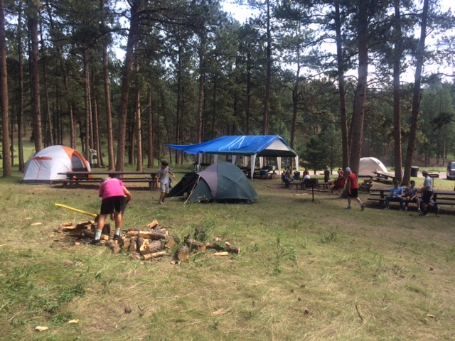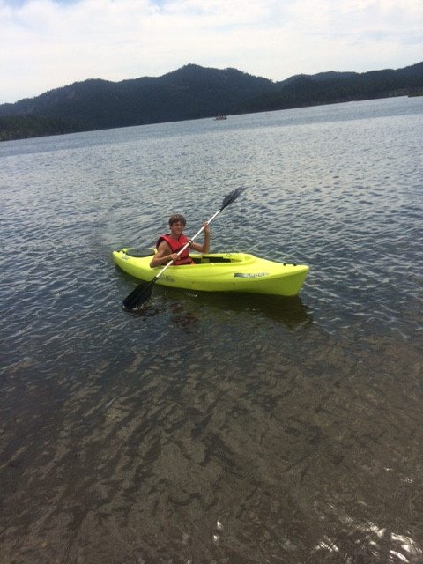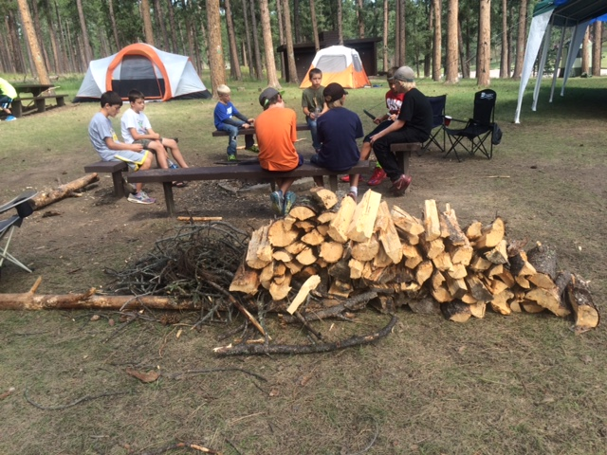
July 30 - August 3
For Boys 4th grade - 12 grade
Sheridan Lake North Shore
Ranger Rick Camp Site
Rapid City, SD
Camp Fees $90.00
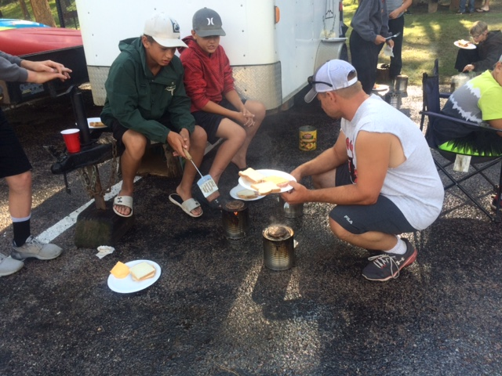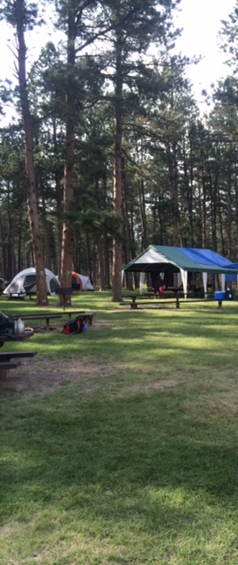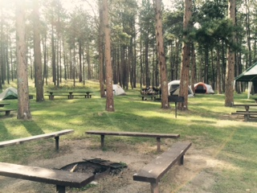

For more information contact Russ Grim Cell 605-830-8911 Home 605-835-9442

